# BC Integrals and Their Applications

## Multiple Choice

1. (calculator not allowed) $\int_{1}^{e}{\frac{x^{2}+1}{x}}dx=$
$\frac{e^{2}-1}{2}$

$\frac{e^{2}+1}{2}$

$\frac{e^{2}+2}{2}$

$\frac{e^{2}-1}{e^{2}}$

$\frac{e^{2}-8e+6}{3e}$

2. (calculator not allowed) $\int_{1}^{∞}{x}e^{-x^{2}}dx$ is
 $-\frac{1}{e}$

 $\frac{1}{2e}$

 $\frac{1}{e}$

$\frac{2}{e}$

1. divergent
3. (calculator not allowed) $∫x^{2}cos\left(x^{3}\right)dx=$
$-\frac{1}{3}sin\left(x^{3}\right)+C$

$\frac{1}{3}sin\left(x^{3}\right)+C$

$-\frac{x^{3}}{3}sin\left(x^{3}\right)+C$

$\frac{x^{3}}{3}sin\left(x^{3}\right)+C$

$\frac{x^{3}}{3}sin\left(\frac{x^{4}}{4}\right)+C$

4. (calculator allowed) 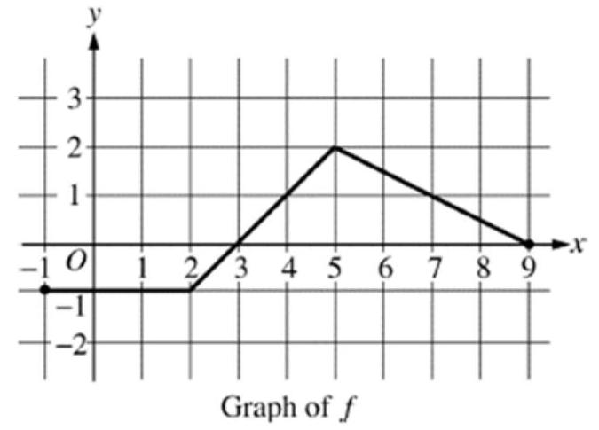 The graph of a piecewise linear function $f$ is given. What is the value of $\int_{-1}^{9}{\left(3f\left(x\right)+2\right)}dx$?
   1. 7.5
   2. 9.5
   3. 27.5
   4. 47
   5. 48.5
5. (calculator not allowed) If $\frac{dy}{dt}=e^{0.2t}$ and if $y=12$ when $t=0$, what is the value of $y$ when $t=10?$
$e^{2}$

$5e^{2}$

$5e^{2}+7$

$\frac{e^{2}-e}{5}+12$

6. (calculator not allowed) Which of the following limits is equal to $\int_{-3}^{1}{e^{x}}dx$?
$\lim_{n→∞}\sum_{k=1}^{n}{\left(e^{\left(\frac{4k}{n}\right)}⋅\frac{4}{n}\right)}$

$\lim_{n→∞}\sum_{k=1}^{n}{\left(e^{\left(-3+\frac{4k}{n}\right)}⋅\frac{1}{n}\right)}$

$\lim_{n→∞}\sum_{k=1}^{n}{\left(e^{\left(\frac{4k}{n}\right)}⋅\frac{1}{n}\right)}$

$\lim_{n→∞}\sum_{k=1}^{n}{\left(e^{\left(-3+\frac{4k}{n}\right)}⋅\frac{4}{n}\right)}$

7. (calculator allowed) If $\int_{1}^{3}{f}\left(x+5\right)dx=7$, then what is the value of $\int_{6}^{8}{\left(f\left(x\right)+2\right)}dx?$
   1. 4
   2. 6
   3. 9
   4. 11
8. (calculator not allowed) A rain barrel collects water off the roof of a house during three hours of heavy rainfall. The height of the water in the barrel increases at a rate of $r\left(t\right)=4t^{3}e^{-1.5t}$ feet per hour, where $t$ is the time In hours since the rain began. At time $t=1$ hour, the height of the water is 0.75 foot. Which of the following is the best interpretation of $\int_{1}^{2}{4}t^{3}e^{-1.5t}dt$?
   1. The average height of the water in the barrel, in feet, over the time interval [1,2] hours after the start of heavy rainfall.
   2. The change in the height of the water in the barrel, in feet, over the time interval [1,2] hours after the start of heavy rainfall
   3. The rate at which the height of the water in the barrel increases, feet per hour, over the time interval [1,2] hour after the start of heavy rainfall.
   4. The height of the water in the barrel, in feet, 2 hours after the start of heavy rainfall.
9. (calculator not allowed) Using the substitution $u=x^{2}-3,\int_{-1}^{4}{x}{\left(x^{2}-3\right)}^{5}dx$ is equal to which of the following?
$2\int_{-2}^{13}{u^{5}}du$

$\int_{-2}^{13}{u^{5}}du$

$\frac{1}{2}\int_{-2}^{13}{u^{5}}du$

$2\int_{-2}^{13}{u^{5}}du$

$\int_{-1}^{4}{u^{5}}du$

10. (calculator not allowed) For what value of $k$, if any, is $\int_{0}^{∞}{k}xe^{-2x}dx=1$?
 $\frac{1}{4}$

   1. 1
    2. 4
    3. There is no such value of $k$.
11. (calculator not allowed) $\int_{1}^{e}{\frac{lnx}{x^{3}}}dx=$
$\frac{e^{2}-3}{4e^{2}}$

$\frac{-e^{2}-3}{4e^{2}}$

$\frac{e^{2}-1}{2e^{2}}$

$\frac{e^{3}-1}{2e^{3}}$

12. (calculator not allowed) Let $f$ be a differentiable function such that $∫f\left(x\right)sinxdx=-f\left(x\right)cosx+∫4x^{3}cosxdx$. Which of the following could be $f\left(x\right)$?
$cosx$

$sinx$

$4x^{3}$

$-x^{4}$

$x^{4}$

13. (calculator not allowed) Which of the following statements about the integral $\int_{-1}^{1}{\frac{1}{x^{2}}}dx$ is true?
    1. The integral is equal to -2 .
    2. The integral is equal to 0 .
    3. The integral diverges because $\lim_{x→0^{-}}\frac{1}{x^{2}}$ does not exist.
    4. The integral diverges because $\lim_{x→0^{-}}\frac{-1}{x}$ does not exist.

| $$X$$ | 0 | 1 |
| --- | --- | --- |
| $$f\left(x\right)$$ | 2 | 4 |
| $$f^{'}\left(x\right)$$ | 6 | -3 |
| $$g\left(x\right)$$ | -4 | 3 |
| $$g^{'}\left(x\right)$$ | 2 | -1 |

1. (calculator not allowed) The table above gives values of $f,f^{'},g$, and $g^{'}$ for selected values of $X$. If $\int_{0}^{1}{f^{'}}\left(x\right)g\left(x\right)dx=5$, then $\int_{0}^{1}{f}\left(x\right)g^{'}\left(x\right)dx=$
   1. -14
   2. -13
   3. -2
   4. 7
   5. 15
2. (calculator not allowed)
$$\int_{1}^{3}{\frac{3x^{3}+15x^{2}+x+9}{x+5}}dx=$$

$28+4\left(ln8-ln6\right)$

$24+4\left(ln8-ln6\right)$

$28+\left(ln8-ln6\right)$

$\frac{51}{2}$

3. (calculator not allowed)
$$∫\frac{7x}{\left(2x-3\right)\left(x+2\right)}dx$$

$\frac{3}{2}ln\left|2x-3\right|+2ln\left|x+2\right|+C$

$3ln\left|2x-3\right|+2ln\left|x+2\right|+C$

$3ln\left|2x-3\right|-2ln\left|x+2\right|+C$

$-\frac{6}{{\left(2x-3\right)}^{2}}-\frac{2}{{\left(x+2\right)}^{2}}+C$

$-\frac{3}{{\left(2x-3\right)}^{2}}-\frac{2}{{\left(x+2\right)}^{2}}+C$

4. (calculator not allowed)
 $$\int_{0}^{\frac{π}{2}}{\frac{cosx}{1+\sin^{2}x}}dx=$$

  1. 0
 $\frac{π}{4}$

 $\frac{π}{2}$

 2. Divergent
5. (calculator not allowed) 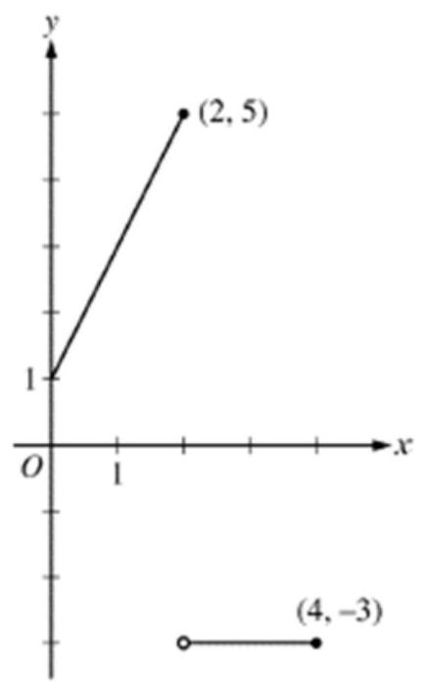 Graph of $f$ The graph of $f$ is shown for $0≤x≤4$. What is the value of $\int_{0}^{4}{f}\left(x\right)dx$?
   1. -1
   2. 0
   3. 2
   4. 6
   5. 12
6. (calculator not allowed) $∫\frac{1}{1+e^{2x}}dx=$
$arctan\left(e^{x}\right)+C$

$ln\left|1+e^{2x}\right|+C$

$x-2ln\left|1+e^{2x}\right|+C$

$x-\frac{1}{2}ln\left|1+e^{2x}\right|+C$

7. (calculator not allowed)
$$∫\frac{1}{x^{2}-10x+34}dx=$$

$ln\left|x^{2}-10x+34\right|+C$

$arctan\left(\frac{x-5}{9}\right)+C$

$\frac{1}{3}arctan\left(\frac{x-5}{3}\right)+C$

$3arctan\left(\frac{x-5}{3}\right)+C$

8. (calculator not allowed) $\int_{0}^{1}{\frac{5x+8}{x^{2}+3x+2}}dx=$
 $ln8$

 $ln\left(\frac{27}{2}\right)$

 $ln18$

$ln288$

1. Divergent
9. (calculator allowed) If $f^{'}\left(x\right)=\sqrt{9-x^{2}}$ and $f\left(-1\right)=2.4$ then $f\left(2\right)=$
   1. 7.5
   2. 6.063
   3. 8.463
   4. 10.863